**CAD Drawings for Bridge Design Project**

3D Model:

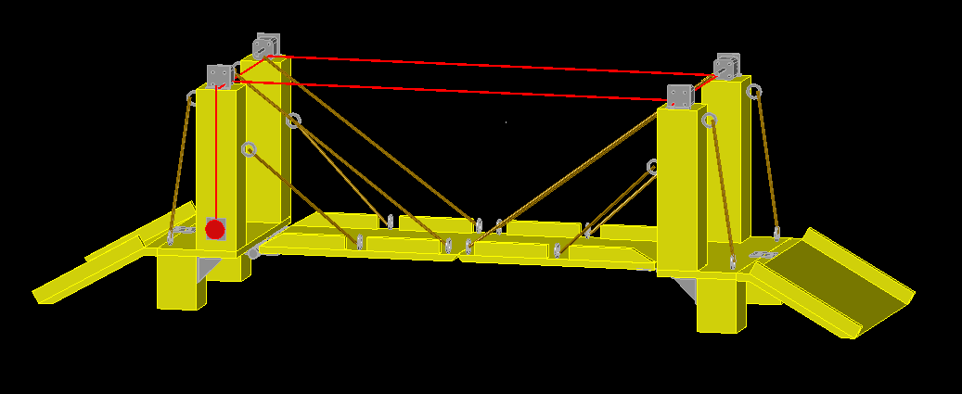

Orthographic Drawing: Drawbridge Left Half

Orthographic Drawing: Drawbridge Left Platform

Orthographic Drawing: Drawbridge Left Pillars

